WISHING WELL FAMILY CENTRE
AUTUMN NEWSLETTER
Wishing Well Family Centre is a locally based integrated, community organisation
that offers support to families, responding in a caring and open way to social, educational, economic and environmental needs within our community.
IMPORTANT DATES TO REMEMBER –
PRE-SCHOOL
CLOSED – MON 30th OCT - WED 1st NOV (inclusive)

DAYCARE
CLOSED – WED 1st NOV 17 – HALLOWEEN

ROOM UPDATES
Throughout September we have been welcoming new children who are settling well and adapting to new routines and environment. A lot of our children have moved rooms and we look forward to watching them continue to grow and develop.

Baby Room
Our monthly plans, which are displayed outside the room show our themes each month which from September to November will include – All about Me, Autumn/Halloween & Transport. The themes are carried through all activities including our story & song time, floor play activities, crafts and decorating our room with family portraits, cars, buses, sponge paintings, pumpkins, ghosts and much more. Laura Burns – Supervisor

Toddler Room
Our theme for September will focus on 'All about Me' we will be decorating the room with family photos, self-portraits as well as hand & foot prints, junk art and free colouring. In October our theme is 'autumn and Halloween,' our shape will be a 'crescent' and colours will be 'orange and black'. We will be decorating the room with bats, ghosts, witches, pumpkins and other Halloween crafts, we also hope to explore our garden for leaves, acorns and conkers for our autumn display. Throughout November we will look at 'Transport' e.g. cars, planes, boats etc. This theme will also be evident through the children's activities e.g. ride along cars, linking vehicles and small world play. Our colour will be 'blue' and our shape 'triangle'. Megan Hale – Supervisor

Junior Playgroup
Our theme for the month of September is 'all about Me & My family’. Our theme will be carried on throughout the room in everything we do. Could I ask parents to bring in a family photograph for our family display. Throughout October & November we will be focusing on 'autumn and Halloween' and our colour will be 'orange'. We will be taking the children on nature walks to collect leaves, acorns and other items to help with our autumn crafts which will be displayed in the room and on our window displays. We also hope the children enjoy our Halloween crafts such as spiders, bats and pumpkins for our mobile display and some cookery activities. In November we will continue to focus on 'autumn' and the changes in the weather, trees etc. Your child’s artwork can be collected at the end of each month in their folder just outside the room. Nuala Heaney – Supervisor

Senior Playgroup
We have enjoyed a very busy summer with trips out to the cinema, Stormont Park,
the Zoo and much more. The senior playgroup is seen as a stepping stone to the Pre School setting, as we introduce the children to the different areas of learning within the curriculum with activities based around our monthly themes. During the month of September the children will be settling into the routines of our room and our theme will be 'All about Me' and 'My Family'. October's theme will focus on 'Halloween and autumn' and in November will be looking at 'transport and road safety'. Every month the children will be encouraged to join in art and craft activities that will be displayed around our room. We hope to continue making use of our back garden and outside play area. During the first few months this room will be quite a challenge for some children as they become independent and are introduced to many new things, which we hope they will enjoy. The children will always be encouraged to make their own choices, contribute to break duties, cleaning teeth and following simple rules. Tracey Massey – Supervisor

Pre School
We would like to welcome all our new children into pre-school and we hope they settle well and enjoy the wide variety of activities on offer. We would also like to introduce you to the staff in our pre-school. Muriel – supervisor level 3, Natasha – deputy level 3 and Kirsty – volunteer level 3. Over the first month or so the children will be settling into the new routine of pre-school. This will involve getting to know the staff and other children, learning how to play together and learning how to follow the routines and structure of the group. For further information regarding our monthly themes and programme please feel free to look at our weekly plans displayed outside our room. Muriel Dalzell - Supervisor

Out of Schools
Our Out of Schools aims to create a safe, stimulating and happy environment for children.
We are very busy on a daily basis helping with homework and art and craft activities. We would like to remind parents if your child is unwell or not attending Out of Schools that you would contact the office before 1pm.

*PLEASE REMEMBER THAT FOR ANY REASON YOUR CHILD DOES NOT ATTEND NURSERY, FEES ARE STILL PAYABLE. THE ONLY TIME FEES ARE NOT PAYABLE IS WHEN THE CENTRE IS CLOSED*

WE WOULD ASK ALL PARENTS TO ADHERE TO SESSION TIMES REGARDING DROP OFF & COLLECTION OF CHILDREN UNLESS OTHERWISE ARRANGED WITH ROOM SUPERVISOR. DROPPING CHILDREN OFF BEFORE SESSION TIMES OR LATE COLLECTION OF CHILDREN CAN EFFECT ROOM RATIO'S AND CAUSE PROBLEMS.

LUNCHES
Lunches are provided in Centre at a price of £2 per day for children
who attend a full day. Our meals are provided by Moon & Spoon a catering
company dedicated to providing wholesome, nutritious food specially designed
for children. For further details please ask at reception.

*In future we will be including an extract from our policies in every newsletter, a full copy of all policies and procedures are available on request from reception.*

Healthy eating policy
We aim to promote healthy eating through snacks we provide and by encouraging parents to provide lunches which are nutritionally balanced.

We encourage this by –
- Fresh fruit is always made available
- We have fresh drinking water constantly available for the children. Children can ask for water at any time during the session. Juice and squash will also be offered at snack times on occasion or at parties.
- Snacks provided by parents will be given throughout the day to help maintain children’s energy.
- Where possible we would encourage that snacks are sugar-free to avoid causing damage to teeth. Fresh fruit is an ideal snack choice.
- Cultural dietary habits are respected. Parents or carers are requested to provide staff with details of foods eaten (and not eaten) by the child.
- Children’s dietary habits are recorded on their registration record form. Also through discussion with parents and research by staff, we obtain information about the dietary rules of religious groups, vegetarian’s, and vegans or about food allergies/intolerances.
- We regularly consult with parents to ensure that our records of their children’s dietary needs – including any allergies – are up to date. The special dietary needs of a child must be checked before any food preparation or cooking activities take place.

SUMMER 2017
Over the summer we had various activities for children Primary 1-7 including
trips to the adventure playground, sports bowl, cinema,
Stormont outdoor park and much more.
We were funded throughout the summer by Belfast City Council.
Firework safety – the basics
Watching fireworks is great fun. But burns from fireworks can be
devastating – and happen very easily if you don’t take the correct safety
precautions. Over 500 children under 16 are rushed to A&E in the four wks.
surrounding Halloween.

Never return to a lit firework.
Never throw fireworks.
Always follow the instructions when using fireworks.

Sparkler safety – the basics
- A sparkler can reach a temperature of up to 2,000 degrees Celsius – 20 times the boiling point of water. And three sparklers burning together generate the same heat as a blowtorch!
- Don’t hold babies and young children while you’re holding a sparkler – they can reach out unexpectedly and grab at them.
- Don’t give sparklers to children under 5. They’re too young to hold them safely and don’t understand why they might be dangerous.

Our new build coming soon …..

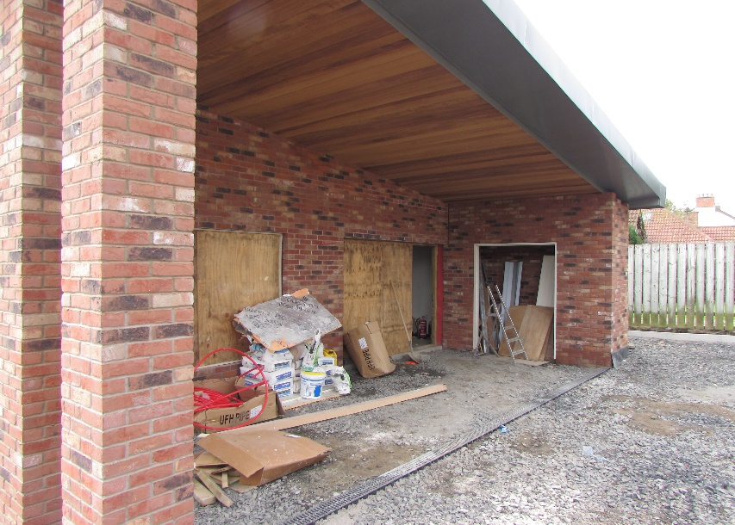
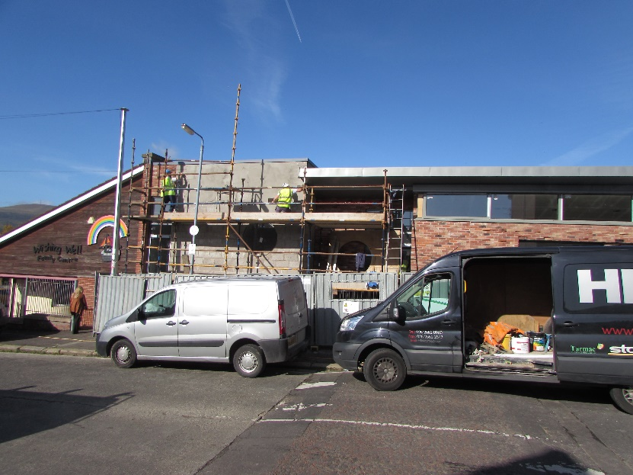

FUNDED BY THE SOCIAL INVESTMENT FUND

WISHING WELL FAMILY CENTRE
7 – 9 ALLIANCE CRESCENT
BELFAST BT14 7PL
02890 740454
www.wishing-well.org.uk

